
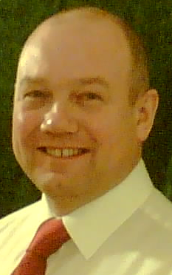

Gary Heather
59 Mayton Street
London
N7 6QP
Mobile: 07918 170 901
Email: gary@garyheather.org
Facebook: www.facebook.com/garyfj.heather
Twitter: http://twitter.com/garyheatherFJ
Islington North CLP
Membership No A006966

gheather@cwu.orgGary Heather
Prospective Parliamentary Candidate
Tunbridge Wells Constituency Labour Party
c/o Len Fagg Hall
71a St John's Road
Tunbridge Wells
Kent
TN4 9TT
07918 170 901
gheather@cwu.org

Dear Member, February 2015

National Constitutional Committee (NCC) elections 2015

I would very much appreciate nomination by your CLP for election to the National Constitutional Committee (NCC). The deadline for nominations to the Labour Party is 10 June, and the election will take place in September at Party annual conference.

A Party member for 25 years, I was chair of my CLP for six years. I have experience as a council and parliamentary candidate. As a trade unionist, I served on the CWU NEC and I am President of Islington TUC. I am also a Fabian and a Co-operative Party member.

I have always taken a strong interest in the rules of the Party, and believe that people receiving justice in society – including in the Labour Party – is a fundamental human right. I have vast experience of dealing with disciplinary matters in my union where I served on the National Discipline Committee and also in assisting members at Employment Tribunals.

I believe in fairness for all, and that includes in the Labour Party. This means that the Party rules must be applied fairly to all, while always looking to resolve disputes and conflict so as to maximise unity and effectiveness within the Party.

Labour has to advocate an alternative to Coalition Government austerity and cuts. I want to end child poverty, improve health and education, end tax avoidance, promote peace and international development, return utilities and the railways to public ownership, build more affordable council and social housing, create employment and improve workers’ rights, and invest in sustainable energy and green jobs.

Thanks for reading this letter and please give serious consideration to nominating me for the NCC.

Yours in comradeship,
Gary Heather

